Landscape With The Fall of Icarus
By William Carlos Williams [1883-1936]

According to Brueghel
when Icarus fell
it was spring

a farmer was ploughing
his field
the whole pageantry

of the year was
awake tingling
near

the edge of the sea
concerned
with itself

sweating in the sun
that melted
the wings' wax

unsignificantly
off the coast
there was

a splash quite unnoticed
this was
Icarus drowning

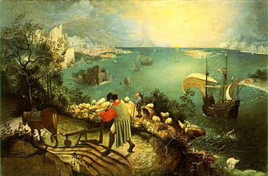
Pieter Bruegel the Elder, Landscape with the Fall of Icarus (c. 1558)
Musee des Beaux Arts
By W. H. Auden [1907-1973]

About suffering they were never wrong,
The old Masters: how well they understood
Its human position: how it takes place
While someone else is eating or opening a window or just walking dully along;
How, when the aged are reverently, passionately waiting
For the miraculous birth, there always must be
Children who did not specially want it to happen, skating
On a pond at the edge of the wood:
They never forgot
That even the dreadful martyrdom must run its course
Anyhow in a corner, some untidy spot
Where the dogs go on with their doggy life and the torturer's horse
Scratches its innocent behind on a tree.

In Breughel's Icarus, for instance: how everything turns away
Quite leisurely from the disaster; the ploughman may
Have heard the splash, the forsaken cry,
But for him it was not an important failure; the sun shone
As it had to on the white legs disappearing into the green
Water, and the expensive delicate ship that must have seen
Something amazing, a boy falling out of the sky,
Had somewhere to get to and sailed calmly on.

The Starry Night
By Anne Sexton [1928-1974]

That does not keep me from having a terrible need of—shall I say the word—religion. Then I go out at night to paint the stars.Vincent Van Gogh in a letter to his brother

The town does not exist
except where one black-haired tree slips
up like a drowned woman into the hot sky.
The town is silent. The night boils with eleven stars.
Oh starry starry night! This is how
I want to die.

It moves. They are all alive.
Even the moon bulges in its orange irons
to push children, like a god, from its eye.
The old unseen serpent swallows up the stars.
Oh starry starry night! This is how
I want to die:

into that rushing beast of the night,
sucked up by that great dragon, to split
from my life with no flag,
no belly,
no cry.

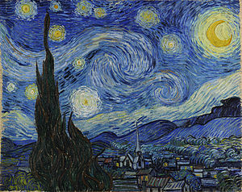
Vincent van Gogh, The Starry Night (1889)
The Starry Night
By Robert Fagles [1933-2008]

Long as I paint
I feel myself
less mad
the brush in my hand
a lightning rod to madness

But never ground that madness
execute it ride the lightning up
from these benighted streets and steeple up
with the cypress look its black is burning green

I am that I am it cries
it lifts me up the nightfall up
the cloudrack coiling like a dragon's flanks
a third of the stars in heaven wheeling in its wake
wheels in wheels around the moon that cradles round the sun

and if I can only trail these whirling eternal stars
with one sweep of the brush like Michael's sword if I can
cut the life out of the beast - safeguard the mother and the son
all heaven will hymn in conflagration blazing down
the night the mountain ranges down
the claustrophobic valleys of the mad

Madness
is what I have instead of heaven
God deliver me - help me now deliver
all this frenzy back into your hands
our brushstrokes burning clearer into dawn.

In Goya’s Greatest Scenes We Seem to See

By Lawrence Ferlinghetti [1919-]

In Goya’s greatest scenes we seem to see
the people of the world
exactly at the moment when
they first attained the title of
‘suffering humanity’
They writhe upon the page
in a veritable rage
of adversity
Heaped up
groaning with babies and bayonets
under cement skies
in an abstract landscape of blasted trees
bent statues bats wings and beaks
slippery gibbets
cadavers and carnivorous cocks
and all the final hollering monsters
of the
‘imagination of disaster’
they are so bloody real
it is as if they really still existed
And they do
Only the landscape is changed
They still are ranged along the roads
plagued by legionnaires
false windmills and demented roosters
They are the same people
only further from home
on freeways fifty lanes wide
on a concrete continent
spaced with bland billboards
illustrating imbecile illusions of happiness
The scene shows fewer tumbrils
but more strung-out citizens
in painted cars
and they have strange license plates
and engines
that devour America

I Am Goya

By Andrey Voznesensky [1933-2010]

I am Goya

of the bare field, by the enemy’s beak gouged

till the craters of my eyes gape

I am grief

I am the tongue

of war, the embers of cities

on the snows of the year 1941

I am hunger

I am the gullet

of a woman hanged whose body like a bell

tolled over a blank square

I am Goya

O grapes of wrath!

I have hurled westward

the ashes of the uninvited guest!

and hammered stars into the unforgetting sky – like nails

I am Goya
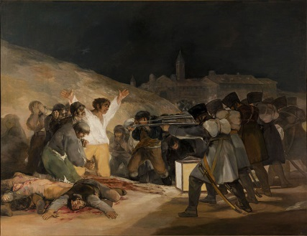
Francisco de Goya, The Third of May, 1808: The Execution of the Defenders of Madrid (1814)
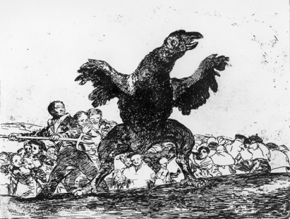
Francisco de Goya, The Disasters of War, the Carnivorous Vulture (c. 1810)
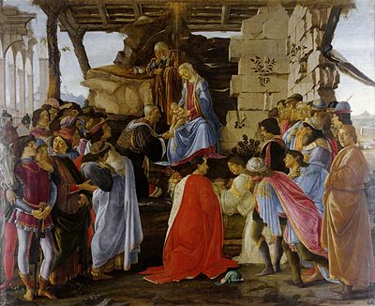Journey of the Magi
Sandro Botticelli, Adoration of the Magi (c. 1475)
By T. S. Eliot [1888-1965]

A cold coming we had of it,
Just the worst time of the year
For a journey, and such a long journey:
The was deep and the weather sharp,
The very dead of winter."
And the camels galled, sore-footed, refractory,
Lying down in the melting snow.
There were times we regretted
The summer palaces on slopes, the terraces,
And the silken girls bringing sherbet.
Then the camel men cursing and grumbling
And running away, and wanting their liquor and women,
And the night-fires gong out, and the lack of shelters,
And the cities hostile and the towns unfriendly
And the villages dirty, and charging high prices.:
A hard time we had of it.
At the end we preferred to travel all night,
Sleeping in snatches,
With the voices singing in our ears, saying
That this was all folly.

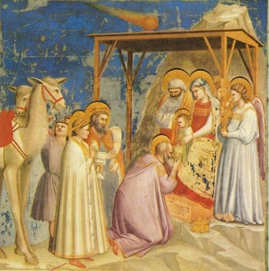
Then at dawn we came down to a temperate valley,
Wet, below the snow line, smelling of vegetation;
With a running stream and a water-mill beating the darkness,
And three trees on the low sky,
And an old white horse galloped away in the meadow.
Then we came to a tavern with vine-leaves over the lintel,
Six hands at an open door dicing for pieces of silver,
And feet kicking the empty wine-skins.
But there was no information, and so we continued
And arrived at evening, not a moment too soon
Finding the place; it was (you may say) satisfactory.

All this was a long time ago, I remember,
And I would do it again, but set down
This set down
This: were we lead all that way for
Birth or Death? There was a Birth, certainly,
We had evidence and no doubt. I have seen birth and death,
But had thought they were different; this Birth was
Hard and bitter agony for us, like Death, our death.
We returned to our places, these Kingdoms,
But no longer at ease here, in the old dispensation,
With an alien people clutching their gods.
I should be glad of another death.

The Magi
By W. B. Yeats [1865-1939]

OW as at all times I can see in the mind's eye,
In their stiff, painted clothes, the pale unsatisfied ones
Appear and disappear in the blue depth of the sky
With all their ancient faces like rain-beaten stones,
And all their helms of silver hovering side by side,
And all their eyes still fixed, hoping to find once more,
Being by Calvary's turbulence unsatisfied,
The uncontrollable mystery on the bestial floor.

Giotto di Bondone, Adoration of the Magi (1313)
The Scream
By Donald Hall [1928-]

Observe. Ridged, raised, tactile, the horror
of the skinned head is there. It is skinned
which had a covering-up before,
and now is nude, and is determined

by what it perceives. The blood not Christ’s,
blood of death without resurrection,
winds flatly in the air. Habit foists
conventional surrender to one

response in vision, but it fails here,
where the painstaking viewer is freed
into the under-skin of his fear.
Existence is laid bare, and married

to a movement of caught perception
where the unknown will become the known
as one piece of the rolling mountain
becomes another beneath the stone

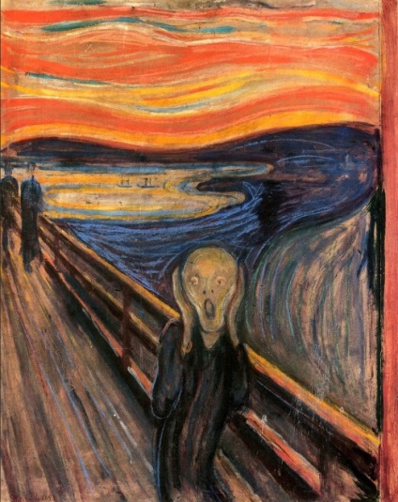which shifts now toward the happy valley
Edvard Munch, The Scream (1893)
which is not prepared, as it could not
be, for the achieved catastrophe
which produces no moral upshot,

no curtain, epilogue, nor applause,
no Dame to return purged to the Manse
(the Manse is wrecked) – not even the pause,
the repose of art that has distance.

We, unlike Munch, observe his The Scream
making words, since perhaps we too know
the head’s “experience of extreme
disorder.” We have made our bravo,

but such, of course, will never equal
the painting. What is the relation?
A word, which is at once richly full
of attributes: thinginess, reason,
reference, time, noise, among others;
bounces off the firm brightness of paint
as if it had no substance, and errs
toward verbalism, naturally. Mayn’t

we say that time cannot represent
space in art? “The fascination of
what’s impossible” may be present,
motivating the artist to move.

So the poet, the talker, aims his
words at the object, and his words go
faster and faster, and now he is
like a cyclotron, breaking into

the structure of things by repeated
speed and force in order to lay bare
in words, naturally, unworded
insides of things, the things that are there.

Rooms by the Sea
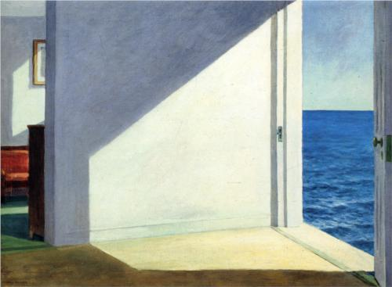
By John Hollander [1929-]
It may recall
An earlier glimpse of emptiness, a corner
Of a room by the sea, opening seemingly
Onto an uncontainable expense of ocean.
The front room,
To step right out of the room in to the sea
Directly, as if the land outside had all vanished with some silent “Boom!”
How wonderfully sudden it would be!
How grandly liberating it could be,
Having swept away all but sunlight with a painter’s broom,
To step wide out of the room out to the sea,
To step straight out of the room onto the sea,
The blue hardwood floor or its surface stretched over an almost bottomless gloom:
How shockingly stabilizing it should be.
How nonchalant yet stirring it might be
Straw-hatted, wearing some buttonhole in yellow bloom,
To step gaily out of the room off to the sea.
To step wrongly out of the room up to the sea,
As if suddenly there were nothing any more about perspective that we could assume,
How seemingly possible, yet it can’t be…
How simple and familiar it shall be
In the broadly ordinary that for the time being remains our doom
To step simply out of the room and down to the sea.
Edward Hopper, Rooms by the Sea (1903)

Jesus and the Woman at the Well
By Marilyn Chandler McEntyre [1949-]

You never know who will be chosen.
A lot of folks who would have loved
to spend half an hour with God Incarnate
didn’t get to.
A lot of those
who had their moment with the Lord
never made it into history. Lost pearls,
those words exchanged along the dusty roads
that no one wrote down.

Then there’s this woman. She’s not a seeker.
She’s just tired of coming all this way
for water, tired of men who take more
than they give, tired of righteous people
who still have their reputations.

She’s no Rebekah, virginal and fair,
nor Rachel, ripe for love, ready with her water jar,
nor Zipporah, grateful for deliverance.

What mockery even to imagine her
among those holy women who found
their bridegrooms waiting by the well.

Baffled again, the disciples wondered:
Why should she be an object of such attention—
not only Samaritan, but a woman
and angry as a shrew? At least the whores
had a little laughter in them.
Odd how he’ll talk to anyone.

Could get him into real trouble
one of these days.
Not to mention
the embarrassment for the rest of us.
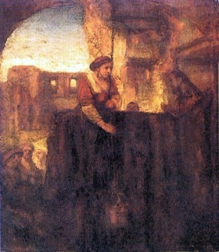
School of Rembrandt Van Rijn, Christ and the Samaritan Woman at the Well (1659)

